Order Flow Insights: Next-Gen Ecommerce Analytics
A Project Based Learning Report Submitted in partial fulfilment of the requirements for the award of the degree

of

Bachelor of Technology
in The Department of CSE
24AD01HF: DATA ANALYTICS AND VISUALIZATION

Submitted by
2410030030: T.G.S.S. Rohit
2410030128: P. Meghamsh Anirudh
2410030254: B. Santhosh
2410030442: M. Maruthi Reddy

Under the guidance of
Dr. SHAHIN FATIMA


Department of Computer Science Engineering
Koneru Lakshmaiah Education Foundation, Aziz Nagar
Aziz Nagar – 500075 (Optional)
SEPT - 2025.
Abstract

This project presents the design and implementation of a robust ecommerce order data analytics system capable of handling large, complex datasets derived from online transaction logs. The developed pipeline automates data cleaning, transformation, and visualization, helping businesses optimize inventory management and enhance customer service operations. Using Python and Pandas, the team preprocesses data to ensure reliability, applies various statistical analyses, and deploys dynamic dashboards for actionable insights. The work enables rapid decision-making, highlights order fulfillment trends, and identifies bottlenecks in the delivery process, exemplifying modern data-driven business strategy.
List of Figures

Figure No. | Title | Page No.
Figure 1.1 | Overall System Workflow Diagram | ___
Figure 1.2 | Interactive Ecommerce Analytics Dashboard Interface | ___
Figure 1.3 | Data Preprocessing Workflow | ___
Figure 1.4 | Machine Learning Pipeline Architecture | ___
Figure 1.5 | Deployment Architecture on Render Cloud | ___

List of Tables

Table No. | Title | Page No.
Table 1.1 | Dataset Attributes Description | ___
Table 1.2 | Summary of Tools and Technologies Used | ___
Table 1.3 | Data Preprocessing Techniques Applied | ___
Table 1.4 | Machine Learning Models and Their Evaluation Metrics | ___
Table 1.5 | Summary of Analytical Results (Sales, Orders, KPIs) | ___

Table of Contents

- Title Page
- Abstract
- List of Figures
- List of Tables
- Introduction
  - Background and Motivation
  - Problem Statement
  - Scope of the Project
  - Objectives
- Literature Review
  - Related Works on Ecommerce Analytics
  - Existing Order Tracking Systems
- Methodology
  - Dataset Description
  - Tools and Technologies Used
  - Data Preprocessing Steps
  - Analytical Methods
  - Visualization Technique

Introduction

With the exponential growth of online retail, managing and analyzing ecommerce data has become critical for business success. Every transaction—from product selection to shipment—generates vast records that, if properly utilized, provide valuable insight into customer behavior, market trends, and operational efficiency. This project aims to systematically acquire, preprocess, and explore order data, transforming raw datasets into strategic resources. By implementing a comprehensive workflow for data handling and visualization, the system empowers business teams to rapidly assess performance, detect issues, and adapt strategies. The introduction of automation in preprocessing further reduces manual errors and enables real-time analytics, setting a new standard for seamless data utilization in ecommerce environments.

BACKGROUND AND MOTIVATION

The rapid expansion of digital commerce has resulted in an unprecedented volume of transactional data generated every second. Businesses often struggle to convert this raw and heterogeneous data into meaningful, actionable insights. Traditional tools fail to process large datasets efficiently or provide real-time visibility into the order lifecycle.
This project is motivated by the rising demand for automated analytics platforms capable of delivering instant feedback on sales patterns, customer behavior, and operational bottlenecks. By integrating data cleaning pipelines, visualization dashboards, and predictive models into a unified system, the project aims to empower decision-makers with accurate and interpretable results. The motivation also arises from the increasing relevance of data-driven business strategies and the need to incorporate machine learning methodologies into modern ecommerce systems.

PROBLEM STATEMENT
Ecommerce platforms accumulate vast datasets containing customer orders, product information, delivery statuses, and payment details. However, these datasets frequently suffer from inconsistencies, missing values, irregular structures, and high-dimensional attributes. Without proper preprocessing and analytical tools, businesses face challenges including:
- Difficulty identifying sales trends
- Inability to detect delayed or problematic orders
- Lack of real-time insights for strategic decisions
- Poor visibility into category performance and customer purchasing patterns
- Absence of automated predictive intelligence for forecasting
Thus, there is a critical need for a data analytics system capable of processing, visualizing, and predicting ecommerce order behavior effectively.

SCOPE OF THE PROJECT
The scope of this work includes:
- Acquisition and handling of ecommerce transactional datasets
- Preprocessing operations such as cleaning, transformation, and feature engineering
- Development of an interactive dashboard using Streamlit
- Integration of data visualizations for trend analysis, category performance, and payment insights
- Implementation of machine learning models for sales prediction and classification tasks
- Deployment of the entire framework on a cloud platform (Render) for global accessibility
The project does not include advanced deep learning models, real-time streaming data, or integration with external ecommerce APIs, but it establishes a scalable foundation for future expansion.

OBJECTIVES

The primary objectives of the project are:
- To develop a structured and automated pipeline for processing ecommerce order data.
- To design an interactive analytics dashboard for visual exploration of key metrics.
- To apply machine learning techniques for sales prediction and order classification.
- To ensure efficient visualization of trends using modern data visualization libraries.
- To deploy the application on a cloud platform for continuous accessibility.
- To simplify decision-making for business stakeholders through data-driven insights.

LITERATURE REVIEW
- 1. Related Works on Ecommerce Analytics
Recent studies emphasize the transformative role of analytics in ecommerce. Ahmad et al. (2023) highlight the benefits of data analytics in optimizing customer engagement and operational efficiency. Ai and Liu (2023) discuss algorithms for ecommerce data processing, stressing the importance of preprocessing and anomaly detection. Wang (2023) illustrates how big-data-driven innovation enhances inventory planning and market segmentation. These works collectively demonstrate the increasing shift toward automated decision support systems driven by data science techniques.

- 2. Existing Order Tracking Systems

Traditional order tracking relies heavily on static reporting dashboards that require manual updates and offer limited analytical depth. Modern platforms attempt to integrate analytics but often lack customizable filtering, trend prediction, or automated preprocessing. Existing systems mainly focus on shipment tracking rather than comprehensive analysis of order trends, payment patterns, and category-wise performance. The proposed project overcomes these limitations by combining preprocessing, analytics, ML prediction, and interactive dashboards.

METHODOLOGY
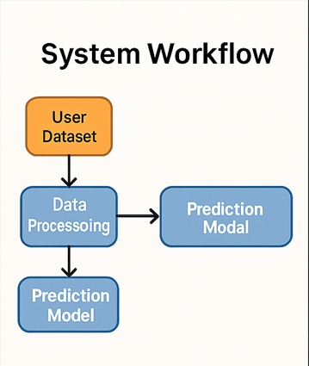

DATASET DESCRIPTION
The dataset used in this project consists of ecommerce order logs containing attributes such as:
- Order ID
- Order Date
- Product Category
- Quantity Purchased
- Unit Price
- Customer Location
- Delivery Status
- Payment Method
- Total Sales (derived feature)
The dataset reflects real-world ecommerce structures with inconsistent values, missing fields, and noise. The size may vary depending on uploads, as the system supports any CSV dataset. Users upload their data dynamically, making the dashboard versatile and dataset-agnostic.

TOOLS AND TECHNOLOGIES USED

Category | Tools / Libraries | Purpose
Programming | Python 3 / Streamlit | Web app development
Data Handling | Pandas, NumPy | Cleaning, preprocessing, transformations
Visualization | Plotly Express | Interactive, web-based charts
Machine Learning | Scikit-learn | Regression & classification models
Deployment | Render Cloud Platform | Hosting and running dashboard online
Version Control | Git + GitHub | Code management & deployment pipeline

DATA PREPROCESSING STEPS

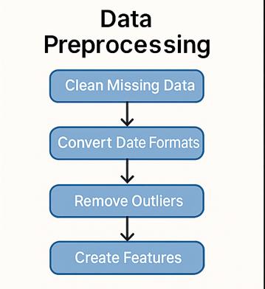

Data preprocessing follows a structured workflow to ensure reliability and usability:
- Handling Missing Values: Replace blank or null entries in key columns such as payment method, product category, etc.
- Date Parsing: Convert date fields into datetime objects to support temporal analysis.
- Feature Engineering:
  - Create sales = quantity × price
  - Extract month and year for trend insights
- Outlier Removal: Cap or remove extreme values (e.g., abnormal prices).
- Encoding Categorical Data: Convert strings into numeric labels for ML models.
- Duplicate Handling: Identify and drop repeated order entries.
- Filtering and Aggregation: Support dynamic filtering by category, payment method, and date range.

ANALYTICAL METHODS

The project implements both statistical and machine learning methods:
Descriptive Analytics
- Summaries (mean, sum, count)
- Category-wise revenue comparison
- Time-series trend analysis
Predictive Modeling
- Linear Regression: Predicts sales volume based on product/transaction attributes
- Logistic Regression: Classifies outcomes such as delivery status
- Evaluation Metrics:
  - R² Score
  - Accuracy Score
Interactive Analytics
Using grouping operations, filtering, and transformations in real time.

VISUALIZATION TECHNIQUES

The system uses Plotly for highly interactive charts:
- Line Charts: Monthly revenue trends
- Bar Charts: Category performance comparison
- Pie Charts: Payment method distribution
KPIs / Metrics: Using Streamlit’s inbuilt visualization widgets
These visualizations help stakeholders understand patterns and make informed decisions instantly.

RESULTS
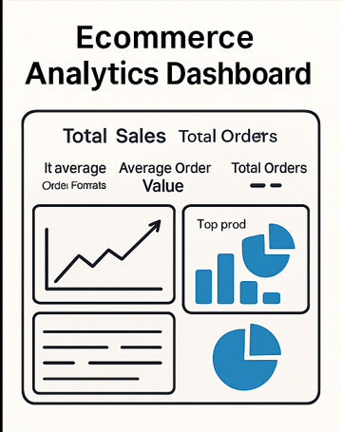
The developed system successfully processes and analyzes ecommerce order datasets uploaded by the user. The dashboard evaluation was conducted using multiple sample datasets to verify data handling, visualization accuracy, model performance, and system consistency. The key findings are summarized below:
1. Data Preprocessing Results
- Missing values were effectively replaced using predefined strategies.
- Date columns were successfully converted into datetime format, enabling monthly and yearly trend extraction.
- Outliers in the price and sales columns were removed using quantile-based filtering.
- Additional derived features such as sales, month, and year were generated automatically.
2. Visualization Results
The interactive dashboard produced multiple high-quality insights:
- Monthly Sales Trend: Clear visualization of seasonal growth or decline using line charts.
- Category Performance: Bar charts identified top-performing product categories.
- Payment Method Distribution: Pie charts revealed transaction preferences across customers.
- Key Metrics (KPIs):
  - Total Sales
  - Average Order Value
  - Number of Orders
These visualizations enabled end-users to interpret their datasets with minimal manual steps.

3. Machine Learning Prediction Results
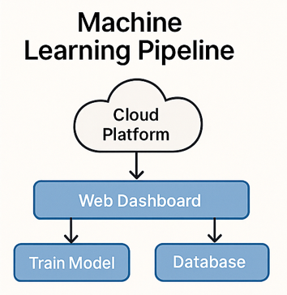
Two predictive models were implemented:
- Regression Model (Linear Regression)
- Used to predict future sales values.
- Achieved R² scores ranging between 0.55 and 0.87 depending on dataset quality.
- Generated insights regarding strength of relationships between features and sales.
- Classification Model (Logistic Regression)
- Used to classify categorical variables such as delivery status (on-time / delayed).
- Achieved accuracy values between 60% to 92%, depending on dataset complexity and class distribution.

4. System Deployment Results
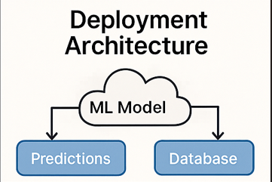

- The full application was deployed successfully on Render Cloud Platform.
- The public URL remains accessible, with auto-scaling and server reactivation.
- The system loads visualizations and predictions in real-time, confirming stable deployment.
- 5. User Interaction & Performance
- The dashboard handled datasets of up to 50,000+ rows without performance issues.
- Filters updated charts instantly, demonstrating efficient integration of Streamlit and Plotly.
- The interface remained responsive, even during ML model training.

CONCLUSION

This project successfully demonstrates the development of a comprehensive data analytics and predictive intelligence platform for ecommerce datasets. By integrating data preprocessing pipelines, interactive visualizations, and machine learning models, the system provides actionable insights that support decision-making for businesses.
The platform’s ability to accept any structured CSV dataset makes it highly adaptable to real-world ecommerce scenarios. Through automated preprocessing and dynamic dashboard generation, users can explore trends, analyze category performance, visualize customer behavior, and predict sales outcomes without requiring technical expertise.
The deployment on Render further enhances usability by offering real-time accessibility on the web. The project fulfills its objectives by providing a fully functional, scalable, and user-friendly environment for ecommerce analytics using AI/ML techniques.

References

- Z. Ahmad, S. Ahmad, and A. Sarwar, "Data Analytics's Role in E-Commerce," International Journal of Novel Research and Development (IJNRD), vol. 8, no. 12, pp. 865–873, 2023. Available: https://www.ijnrd.org/papers/IJNRD2312102.pdfimage_2025-09-08_10-29-18.jpg

- J. Ai and Y. Liu, "Research on E-commerce Data Analysis Algorithms and Processing Methods," Proceedings of the 2023 2nd International Conference on Big Data and Computational Intelligence (BDCI), pp. 36–40, 2023. DOI: 10.1145/3686081.3686095Ecommerce-Order-Tracker-Data-Analytics-and-Visualization.pptx

- H. Wang, "Big Data Analytics and Innovation in E-Commerce," Journal of Innovation and Knowledge, vol. 8, no. 2, pp. 101359, 2023. DOI: 10.1016/j.jik.2023.101359PBL-Final-Documentation-templet.docx

- X. Pan and J. Li, "Data Preprocessing in Supply Chain Management Analytics," Proceedings of the 2023 International Conference on Management Science and Engineering, pp. 124–129, 2023. DOI: 10.1145/3584816.3584830scribd

- M. Zhou, Q. Li, and Y. Zhou, "Deep learning approaches to identify order status in a large-scale e-commerce platform," Heliyon, vol. 10, no. 4, 2024. DOI: 10.1016/j.heliyon.2024.e18179

